# CS 255 System Design Document

## UML Diagrams

### UML Use Case Diagram

### UML Activity Diagrams

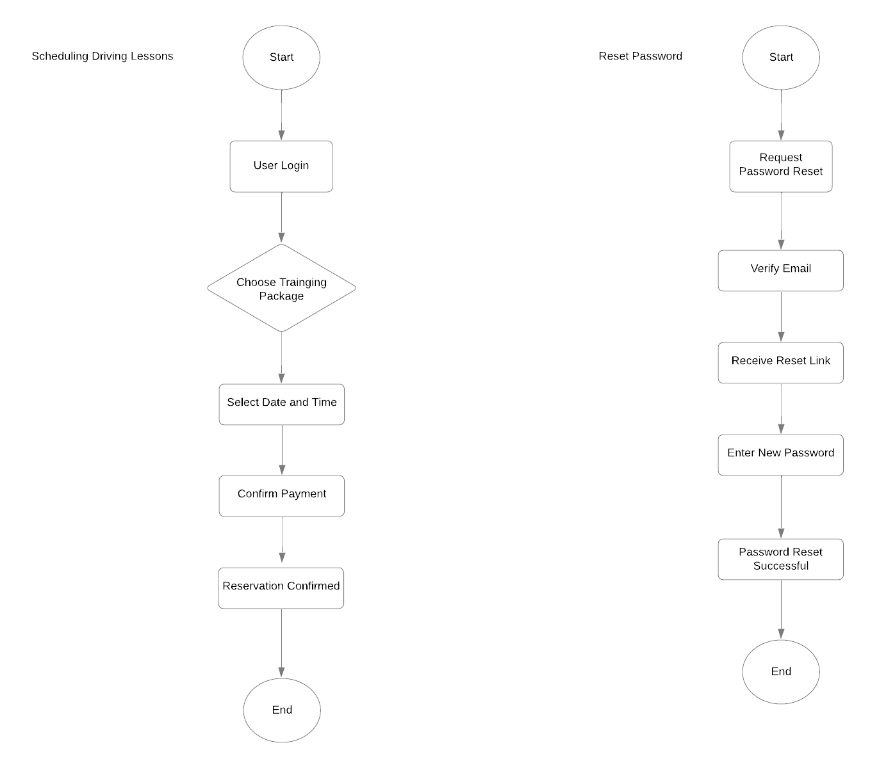

### UML Sequence Diagram

### UML Class Diagram

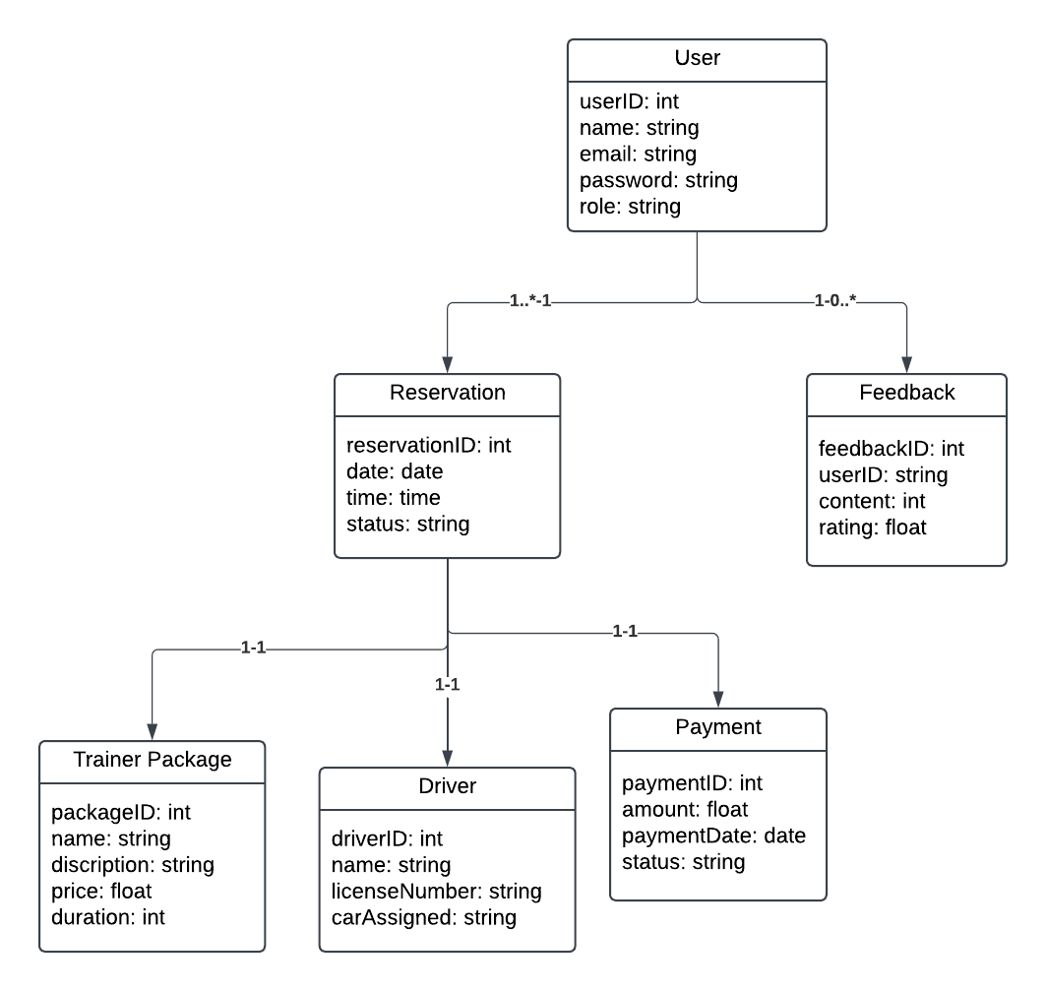

## Technical Requirements

**Hardware Requirements**

* Server Infrastructure: Cloud-based servers to host the system, ensuring scalability and high availability (Amazon Web Services, n.d.).
  + Minimum configuration:
    - Processor: Quad-core 2.4 GHz or higher.
    - RAM: 16 GB or more.
    - Storage: 500 GB SSD (expandable based on growth).
* Client Devices:
  + Desktop or laptop computers with 4 GB RAM or more (Dennis, Wixom, & Tegarden, 2015).
  + Mobile devices with internet access.

**Software Requirements**

* Operating Systems:
  + Server: Compatible with Linux or Windows Server (Sommerville, 2016).
  + Client: Support for Windows, macOS, iOS, and Android.
* Database:
  + SQL-based database management system to handle user accounts, reservations, and training packages (PostgreSQL Global Development Group, n.d.).
* Web Servers:
  + Apache HTTP Server or Nginx to host the application (Nginx Inc., n.d.).
* Programming Languages:
  + Backend: Python or Java.
  + Frontend: JavaScript for dynamic, responsive user interfaces (Dennis, Wixom, & Tegarden, 2015).

**Tools**

* CASE Tool:
  + Lucidchart for creating UML diagrams (Dennis, Wixom, & Tegarden, 2015).
* Development Tools:
  + Integrated Development Environments (IDEs) like PyCharm, VSCode, or IntelliJ IDEA (Sommerville, 2016).
* Testing Tools:
  + Selenium for automated testing.
  + Postman for API testing (Sommerville, 2016).

**Infrastructure Requirements**

* Cloud Hosting:
  + AWS, Microsoft Azure, or Google Cloud for hosting web applications and databases.
  + Use of a load balancer for traffic management (Amazon Web Services, n.d.).
* Networking:
  + Secure internet connection with support for HTTPS (SSL/TLS) encryption (Nginx Inc., n.d.).
* Backup and Recovery:
  + Daily automated backups to ensure data safety and quick recovery in case of failure (Amazon Web Services, n.d.).
* Integration Requirements:
  + Connection to DMV systems for updated test content and notifications (Sommerville, 2016).

**Security Requirements**

* Role-based access control (RBAC) for different user levels (admin, secretary, customer) (Dennis, Wixom, & Tegarden, 2015).
* Encryption:
  + Passwords hashed using algorithms like bcrypt or Argon2.
  + Data transmission secured with SSL/TLS (Nginx Inc., n.d.).
* Brute-force protection:
  + Account lockout after multiple failed login attempts.
* Secure payment integration with PCI DSS compliance (Amazon Web Services, n.d.).

**Resources:**

Dennis, A., Wixom, B. H., & Tegarden, D. (2015). Systems analysis and design: An object-oriented approach with UML (5th ed.). Wiley.

Sommerville, I. (2016). Software engineering (10th ed.). Pearson.

Nginx Inc. (n.d.). Nginx documentation. Retrieved from https://docs.nginx.com/

PostgreSQL Global Development Group. (n.d.). PostgreSQL documentation. Retrieved from https://www.postgresql.org/docs/

Amazon Web Services (AWS). (n.d.). AWS documentation. Retrieved from https://aws.amazon.com/documentation/